<https://www.learnentityframeworkcore.com/lazy-loading>

<https://ardalis.com/avoid-lazy-loading-entities-in-asp-net-applications>

<https://medium.com/@thepen0411/web-crawling-tutorial-in-c-48d921ef956a>

<http://engineerverse.com/new-technology/web-crawler-csharp-tutorial-example-capturing-big-data/>

<https://docs.microsoft.com/en-us/dotnet/machine-learning/automate-training-with-model-builder#how-long-should-i-train-for>

<https://www.guru99.com/selenium-csharp-tutorial.html>

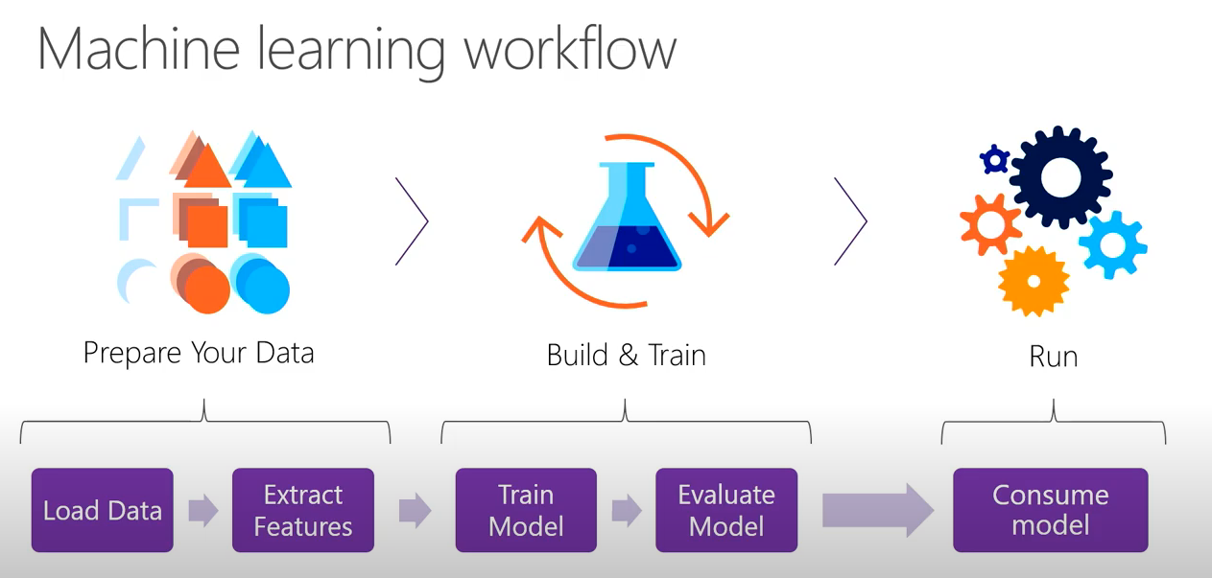

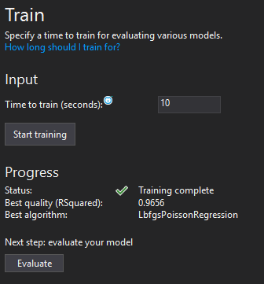

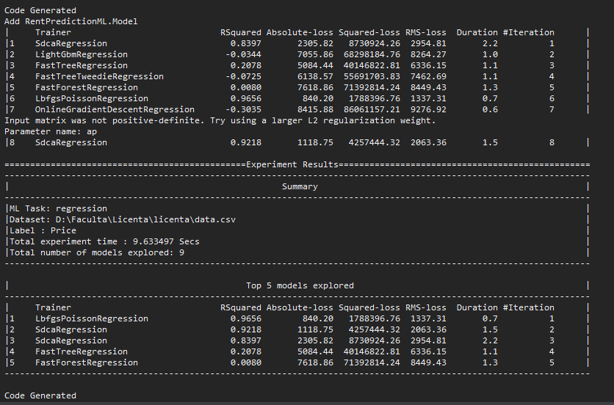

The following algorithms are re-trainable in ML.NET:

* [AveragedPerceptronTrainer](https://docs.microsoft.com/en-us/dotnet/api/microsoft.ml.trainers.averagedperceptrontrainer)
* [FieldAwareFactorizationMachineTrainer](https://docs.microsoft.com/en-us/dotnet/api/microsoft.ml.trainers.fieldawarefactorizationmachinetrainer)
* [LbfgsLogisticRegressionBinaryTrainer](https://docs.microsoft.com/en-us/dotnet/api/microsoft.ml.trainers.lbfgslogisticregressionbinarytrainer)
* [LbfgsMaximumEntropyMulticlassTrainer](https://docs.microsoft.com/en-us/dotnet/api/microsoft.ml.trainers.lbfgsmaximumentropymulticlasstrainer)
* [LbfgsPoissonRegressionTrainer](https://docs.microsoft.com/en-us/dotnet/api/microsoft.ml.trainers.lbfgspoissonregressiontrainer)
* [LinearSvmTrainer](https://docs.microsoft.com/en-us/dotnet/api/microsoft.ml.trainers.linearsvmtrainer)
* [OnlineGradientDescentTrainer](https://docs.microsoft.com/en-us/dotnet/api/microsoft.ml.trainers.onlinegradientdescenttrainer)
* [SgdCalibratedTrainer](https://docs.microsoft.com/en-us/dotnet/api/microsoft.ml.trainers.sgdcalibratedtrainer)
* [SgdNonCalibratedTrainer](https://docs.microsoft.com/en-us/dotnet/api/microsoft.ml.trainers.sgdnoncalibratedtrainer)
* [SymbolicSgdLogisticRegressionBinaryTrainer](https://docs.microsoft.com/en-us/dotnet/api/microsoft.ml.trainers.symbolicsgdlogisticregressionbinarytrainer)

<https://docs.microsoft.com/en-us/dotnet/machine-learning/resources/glossary>

<https://docs.microsoft.com/en-us/dotnet/machine-learning/how-to-guides/save-load-machine-learning-models-ml-net>

<https://blog.mailtrap.io/send-emails-in-net/>

<https://docs.aspnetzero.com/en/aspnet-core-angular/latest/Features-Angular-Forgot-Password>

<https://www.parsehub.com/blog/what-is-web-scraping/>

<http://www.monitorulcj.ro/economie/65357-chiriile-au-crescut-la-cluj-cu-doua-luni-inaintea-inceperii-unui-nou-an-universitar#sthash.S3rVnSWI.dpbs>

<https://economie.hotnews.ro/stiri-finante_banci-23504452-analiza-rata-sau-chirie-cum-mai-avantajos-evolutia-preturilor-chirii-din-aceasta-toamna-marile-orase.htm>

<https://www.economica.net/cererea-de-pe-piata-chiriilor-creste-ca-de-altfel-si-preturile-de-inchiriere-ale-locuintelor_180072.html>

<http://stories.studentpress.ro/2019/07/11/preturile-chiriilor-din-cluj-sunt-mereu-in-crestere/>

<https://www.ziardecluj.ro/legendarele-chirii-din-cluj-incep-timid-sa-scada>

<https://realestatemagazine.ro/2019/09/cluj-napoca-cele-mai-ridicate-preturi-la-chiriile-pentru-apartamente-in-septembrie/>

<https://www.jstor.org/action/doBasicSearch?Query=romania&prq=real+estate+in+europe&swp=on&hp=25&so=rel>

<https://www.c-sharpcorner.com/article/how-to-generate-a-random-password-in-c-sharp-and-net-core/>